**EXERCISES REVIEW**

**Ex1**. Write a program that will print out the sum of integers inputted by user. The input will terminate if user enters the value 0.

**Ex2**. Write a program that permits user entering some characters until the ENTER key (code 10) is pressed. The program will print out the number of digits, number of letters, number of other keys were pressed

**Ex3**. Write a program that print out any multiplication table

**Ex4**. Develop a program that will accept a positive integer then sum of it’s divisors is printed out.

**Ex5**. Develop a program that will accept 3 resistances of a paralleled circuit and their equivalent is printed out.

**Ex6**. Develop a program that will print out **n** first primes.

**Ex7**. Develop a program that will accept two positive integers then print out the greatest common divisor (UCLN) and the least common multiple (BCNN) of them.

**Ex8**. Write a C program that will accept a non-negative integer then print out whether this number is power of 2 or not.

**Ex9**. Write a C program that will

* + Accept 3 integers m, d, y that represent a date.
  + Print out they are valid or not.
  + Attention:
    - The February in a leap year will have 29 days.
    - If Y is a leap year then (Y%4==0 && Y%400 !=0) || (Y%100==0)

**Ex10**. Develop a C-program that allows user choose one task at a time:

1- Test whether a character is a vowel or not.

2- Print out sum of divisors of an integer.

3- Test whether an integer is a prime or not.

**Ex11**. Write a C program using dynamic allocating memory to allow user entering two characters then the program will print out characters between these in ascending order.

**Ex12**. Write a C program using the following menu:

1- Operation 1

2- Operation 2

Others- Quit

* If user chooses 1, user will input 2 integers, the program will print out sum of integers between them including them.
* If user chooses 2, user will input 2 characters, the program will print out the ASCII table between two inputted characters in ascending order.
* If user chooses other options, the program will terminate.

**Ex13**. Write a C program using the following simple menu:

1- Processing date data

2- Character data

3- Quit

Choose an operation:

* When user chooses 1: User will enter values of date, month, year then the program will announce whether this date is valid or not.
* When user chooses 2: User will enter two characters, then the program will print out ASCII codes of characters between them using descending order. Examples: Input: ca

Output: c: 99, 63h

b: 98, 62h

a: 97, 61h

**Ex14**. Write a C program using the following simple menu:

1- Quadratic equation ( phương trình bậc 2)

2- Bank deposit problem

3- Quit

Choose an operation:

* When user chooses 1: User will enter values describing a quadratic equation then the program will print out its solution if it exists.
* When user chooses 2: User will enter his/her deposit ( a positive number), monthly rate ( a positive number but less than or equal to 0.1), number of months ( positive integer), then the program will print out his/her amount after this duration.

**Ex15**. **Develop a C-program that will:** Accept values to an integer array that may contains 100 elements. The input will terminate when user enters the value of zero.

* + Print out the it’s maximum value.
  + Print out it’s elements.
  + Print out it’s even values.

**Ex16**. Develop a C-program that helps user managing an 1-D array of integers (maximum of 100 elements) using the following simple menu:

1- Add a value

2- Search a value

3- Remove the first existence of a value

4- Remove all existences of a value

5- Print out the array

6- Print out the array in ascending order (positions of elements are preserved)

7- Print out the array in descending order (positions of elements are preserved)

Others- Quit

**Ex17**. Develop a C-program that helps user managing an 1-D array of real numbers(maximum of 100 elements) using the following simple menu:

1- Add a value

2- Search a value

3- Print out the array

4- Print out values in a range (minVal<=value<=maxVal, minVal and maxVal are inputted)

5- Print out the array in ascending order (positions of elements are preserved)

Others- Quit

**Ex18**. Write a C program that will accept 10 names, print out the list, sort the list using ascending order, print out the result.

**Ex19**. Write a C-program that helps user managing a list of 100 student names using the following menu:

1- Add a student

2- Remove a student

3- Search a student

4- Print the list in ascending order

5- Quit

**Ex20**. Write a program to read from keyboard the width and the height of a rectangle (the width and the height of this rectangle are integers) then display area of this rectangle on the screen

**Ex21**. Given two integer values a and b. Write a program that accepts a and b and swap the value of a and b. Then print the result on the screen

**Ex22**. Write a program to accepts an integer n from the user then check whether n is an even or odd number

**Ex23**. Write a program that accepts three integers from the user and prints the biggest number among them on the screen

**Ex24**. Write a program that accepts an integer n from the user then displays all numbers from n to -5 (n >= -5) in descending order

**Ex25**. Write a program that accepts two integers a and b from the user and displays the sum of all the numbers from a to b on the screen

**Ex26**. Write a program that accepts an integer n from the user and displays the sum of all odd numbers from 0 to n on the screen

**Ex27**. Write a program that accepts an integer n from the user and prints the divisors of n (n > 0) on the screen.

**Ex28**. Write a program that accepts an integer n and prints all even numbers from n to 100 on the screen

**Ex29**. Write a program to print all numbers from 1 to 1000 (including 1 and 1000), which end with 0. It means the program will display 10, 20, 30, ..., 990, 1000 on the screen.

**Ex30**. Write a program to Find the Roots of a Quadratic Equation tìm nghiệm của pt bậc 2

**Ex31**. In some card games, a numbered card is worth its face value, the Jack, Queen and King, are worth 11 points each and the Ace is worth 1 point.

Write a program that accepts the rank of a card and displays the point value of that card.  The user enters '0' for the number 10 card.  Use an **if else** construct for your first version of the program

**Ex32**. Write a program that does the following steps:

* + Accept an integer n>0 from the keyboard
  + Calculate F1(n) = n!
  + Calculate F2(n) = 1+2+…+n
  + Enter an integer m then calculate nm

**Ex33**. Write a function that prints all numbers from 1 to 100

**Ex34**. Write a function to print all the numbers from 1 to 100, which are divisible by 3 and not divisible by 5

**Ex35**. Write a function to find all the prime numbers between the two integers, checkPrimeNumber() is a function created. A prime number is a positive integer that is divisible only by 1 and itself. For example: 2, 3, 5, 7, 11, 13, 17

**Ex36**. Write a program in C to convert decimal number to binary number using the function

**Ex37**. Write a program in C to find the sum of the series 1!/1 + 2!/2 + 3!/3 + 4!/4 + 5!/5 using the function.

**Ex38**. Write a program in C to check a given number is even or odd using the function.

**Ex39**. Write a program that either calculates the value of an integer raised to the power of an integer exponent or the arithmetic mean of a series of integers, depending upon a choice made by the user.

* + list all of the tasks that the program should perform to solve this problem
  + identify the modules for the problem structure
  + check that each module is high in cohesion
  + check that each module is low in coupling

**Ex40**. Write a short C program that declares and initializes (to any value you like) a double, an int, and a char. Next declare and initialize a pointer to each of the three variables. Your program should then print the address of, and value stored in, and the memory size (in bytes) of each of the six variables.

**Ex41**. Write a program, use the pointer to enter a sequence of integers consist N element. Ouput to screen:

• Maximum value of the element in array

• Minimum value of the element in array

• Sum the elements in array

**Ex42**. Write a program in C to find the second smallest element in an array

**Ex43**. Write a program that accepts a string from the user then count total number of alphabets, digits and special characters in a string and print on the screen.

**Ex44**. Write a program that accepts a string from the user then find maximum occurring character in a string

**Ex45**. Write a program to read a string through keyboard and sort a string array in ascending order.

**Ex46**. Write a program in C to extract a substring from a given string

***Input****:*   
Input the string: FPT University major in software engineering   
Input the position to start extraction: 5  
Input the length of substring: 3

**Output** :

The substring retrieve from the string is: Uni

**Ex47**. Write a program that accepts a string through keyboard from the user then find the largest and smallest word in this string.

***Input***:   
Input the string : FPT University major in software engineering

**Expected Output :**

The largest word is: engineering

The smallest word is: in

**Ex48**. Write a program that accepts an array arr of n integers and prints the sum of the first element and the last element in arr on the screen.

For example, if n = 5, arr = [2, 7, 6, 8, 9], enter the following values:

5 
2 7 6 8 9 

When the code is compiled and executed, it produces the following result:

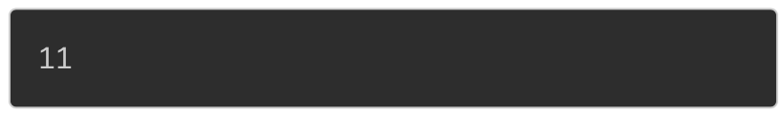

**EX49**. Write that accepts an array arr of n integers from the user and prints all even numbers in arr on the screen.

For example, if you enter the following values:

5 
2 7 6 8 9 

The code will produce the following result:

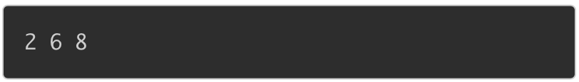

**EX50**. Given an array arr of n integers and an integer k. Write a program that accepts these variables from the user and prints the number of elements in arr, which are equal to k.

For example, if n = 6, arr = [3, 8, 7, 8, 3, 3], k = 3, enter the following values:

6 
3 8 7 8 3 3 
3 

When the code is compiled and executed, it produces the following result:

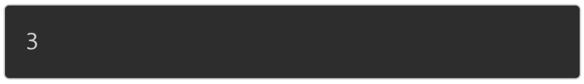

**EX51**. Given an array arr of n integers. Write a program to return the sum of odd numbers in arr, which are greater than 0.

For example, if you enter the following values:

8 
3 -7 2 59 -6 10 12 

The code will produce the following result:

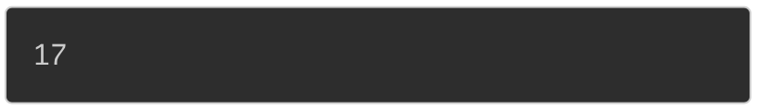

Because 3 + 5 + 9 = 17

**EX52**. Given an array arr of n integers. Write a program that accepts array arr and displays all numbers in arr, which are greater than or equal to 0 and less than or equal to 10.

For example, if you enter the following values:

8 
3 -7 2 59 -6 10 12 

When the code is compiled and executed, it produces the following result:

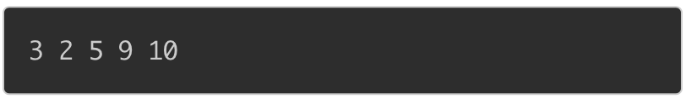

**EX53**. Given an array arr of n elements. Write a program to sort all elements in ascending order and print the sorted array on the screen.

For example, if n = 6, arr = [5,3,2,6,7,7], enter the following values:

6 
5 3 26 7 7 

When the code is compiled and executed, it produces the following result:

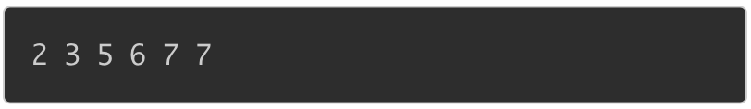

**EX54**. Write a program in C to copy the elements of one array into another array.

-----

***Test Data*** :

Input the number of elements to be stored in the array :3

Input 3 elements in the array :

element - 0 : 15

element - 1 : 10

element - 2 : 12

-----

***Expected Output*** :

The elements stored in the first array are :

15 10 12

The elements copied into the second array are :

15 10 12

**EX55**. Write a program in C to merge two arrays of same size sorted in decending order.

-----

***Test Data*** :

Input the number of elements to be stored in the first array :3

Input 3 elements in the array :

element - 0 : 1

element - 1 : 2

element - 2 : 3

Input the number of elements to be stored in the second array :3

Input 3 elements in the array :

element - 0 : 1

element - 1 : 2

element - 2 : 3

-----

***Expected Output*** :

The merged array in decending order is :

3 3 2 2 1 1

**EX56**. Write a program in C to count a total number of duplicate elements in an array.

-----

***Test Data:***

Input the number of elements to be stored in the array :3

Input 3 elements in the array :

element - 0 : 5

element - 1 : 1

element - 2 : 1

-----

***Expected Output*** :

Total number of duplicate elements found in the array is : 1

**EX57**. Write a program in C to print all unique elements in an array.

-----

***Test Data***:

Print all unique elements of an array:

------------------------------------------

Input the number of elements to be stored in the array: 4

Input 4 elements in the array :

element - 0 : 3

element - 1 : 2

element - 2 : 2

element - 3 : 5

-----

***Expected Output*** :

The unique elements found in the array are:

3 5

**STRING exercises**

**Ex58**. Write a program that accepts a string str from the user and displays str on the screen.

For example, if you enter the following string:

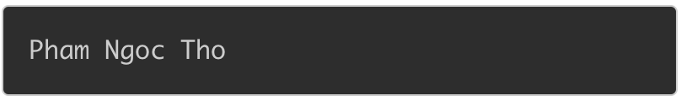

The output should be:



**Ex59**. Write a program that accepts a name and address of a person from the keyboard and displays information on the screen as below:

Name: {PI} 
Address: {P2} 

Where {P1} is the name and {P2} is the address of that person.

For example, if you enter the following values:

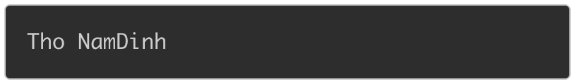

the code will produce the following result:

Name: Tho 
Address: NamDinh 

**Note:** do not enter the name or address having spaces

**Ex60**. Write a program that accepts a string s and an integer k from the user and displays the k'th character in string s.

For example, if s = "fpt\_university", k = 6, enter the following values:

fpt_university 
6 

When the above code is compiled and executed, it produces the following result:

/var/folders/g3/g_dd6w4d6h5ck184w6xhyz_h0000gn/T/com.microsoft.Word/WebArchiveCopyPasteTempFiles/cid237ECA6F-EFE4-DB4A-A7CA-18C28B851E4C.png

Because the second character in fpt\_university is n

**Ex61**. Write a program that accepts a string str from the user and displays the length of the given string on the screen.

For example, if you enter the following value:

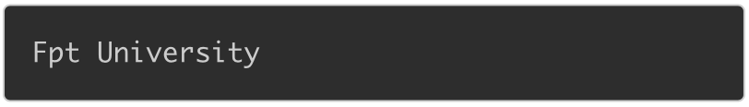

The code will produce the following result:

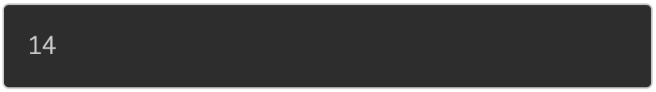

**Ex62**. Given a string s and a character c. Write a program that accept these two variables from the user and prints the occurences of character c in s.

For example, if s = "Codelearn", c = 'e', enter the following values:

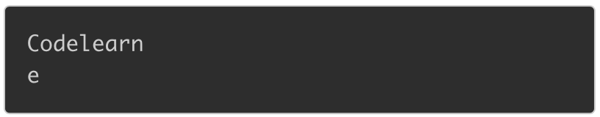

When the code is compiled and executed, it produces the following result:



Because 'e' appears 2 times in "Codelearn"

**Ex63**. Write a program that accepts a string s from the user and replaces all character '3' in s with character 'e' then prints the converted string on the screen.

For example, if s = "cod3l3arn", enter the following string:

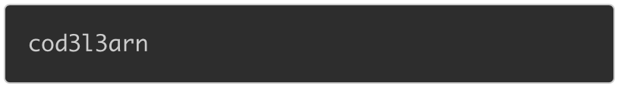

When the code is compiled and executed, it produces the following result:

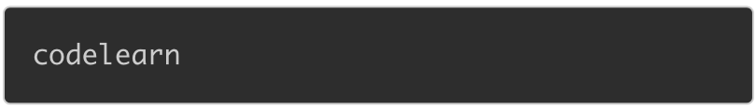

**Ex64**. Given a string s and a character c. Write a program that accepts these two variables from the user and finds the first occurrence of c in string s. If character c does not appear in s, print -1.

For example, if s = "codelearn" and c = 'o', enter the following values:

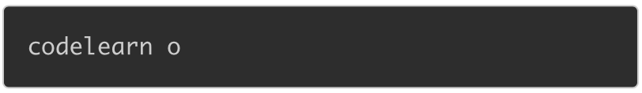

When the code is compiled and executed, it produces the following result:

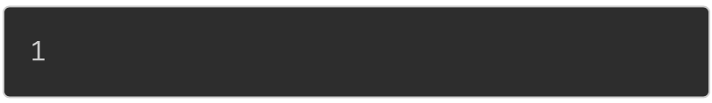

Because the first occurrence of 'o' is at position 1

If you enter the following values:

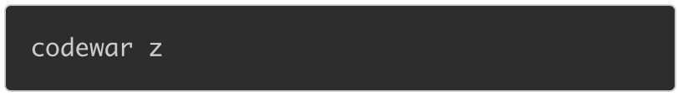

When the code is compiled and executed, it produces the following result:

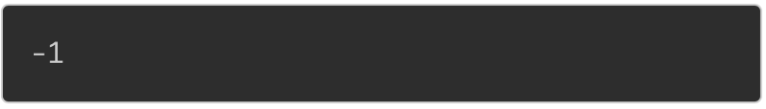

Because 'z' does not appear in string "codewar".

**Ex65**. Given a string s. Write a program that accepts a string s from the user and converts lowercase characters in s to uppercase characters then prints the converted string on the screen:

For example, if s = "Codelearn", enter the following values:

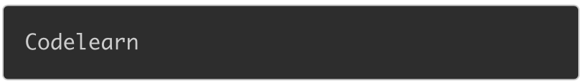

When the code is compiled and executed, it produces the following result:

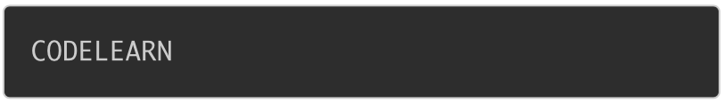

**Ex66**. Write a program that accepts the names of two people from the user then checks whether these two names are the same or not.

If two names are the same, print the following line on the screen:

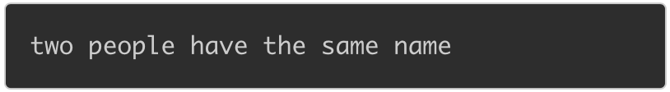

If two names are different, print the following line on the screen:

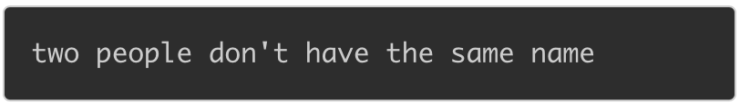

**Ex67**. Write a program to print all characters from 'A' to 'Z' as below:



**Ex68**. Consider the following programs

int main ( ) { 
char s [10] 
scanf ("%s" , 
return O; 
int main ( ) { 
char s [10] 
scanf ('1% [A\n] " , 
return O; 
int main ( ) { 
char s [10] 
gets (s) ; 
return O; 
void getstr (char 
int main ( ) { 
char s [10] 
getstr (s, 9) ; 
return O; 
int) ; 
void getstr (char s [ ] 
int i, c; 
int max) 
while ( (c = getchar ( ) ) 
if (i < max) 
s [i++] = (char) 
EOF) 
c; 

Fill in the following table to show the data stored in **s** by each of these programs

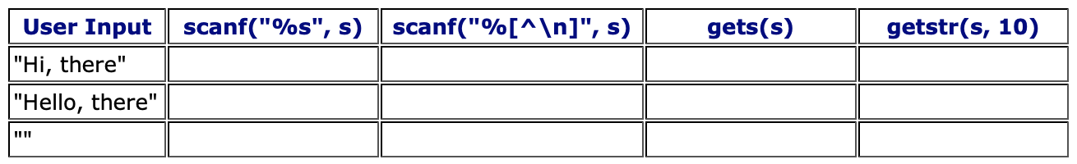

Compare your answers with those of one of your collegues and make sure that the two of you agree.

**Ex69.** Design and code a function named **wordCount** that receives a null terminated string of text and returns the number of words contained in the string.  Consider a word to be any sequence of non-whitespace characters.

The whitespace characters include newline, horizontal tab, form feed, vertical tab and space characters.

Finally, write a program that accepts a string to be counted and displays the number of words in the string.  You may assume that the user will not input a string that contains more than 100 characters, but may input an empty string.

The output from your program looks something like like:

Word Counter 
String to be counted 
Nur±er of words in the 
BTPIOO 
is not 
string : 5 
that 
hard ! 

Write a program that performs the following works:

1. Input integer number n.

2. Calculate S1 = 1 + 2 + 3 + ... + n

3. Calculate S = n!

4. Calculate

S2 =1+++...+

The output from your program looks something like:

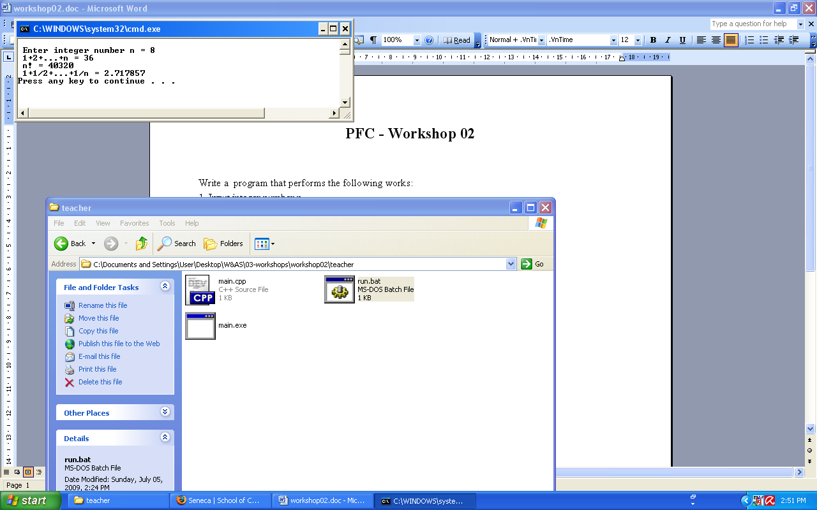

|  |
| --- |
| **Ex70**: Write a program to print an inverted right triangle pattern. |
| **Ex71**: Write a program to print a square pattern. |
| **Ex72**: Write a program to print a hollow square pattern. |
| **Ex73**: Write a program to print a right triangle pattern using numbers. |
| **Ex74**: Write a program to print a diamond pattern. |
| **Ex75**: Write a program to print a pyramid pattern. |
| **Ex76**: Write a program to print a hollow diamond pattern. |
| **Ex77**: Write a program to print an hourglass pattern. |
| **Ex78**: Write a program to print a butterfly pattern. |